TUTORIAL: GIT AND GITHUB 4. GITHUB ACCOUNT AND SSH KEY - 2018

Setting up a GitHub Account

To setup a GitHub account, please check <https://github.com/>.



We want to create a new Repository:



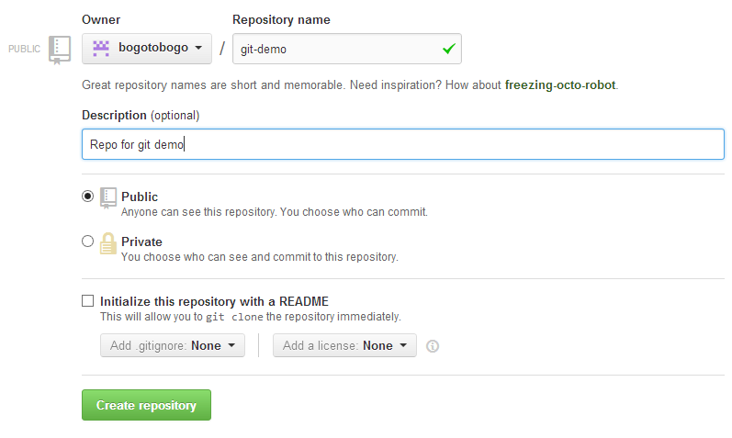

Then, a guide page pops up that has git commands which are familiar to us now:

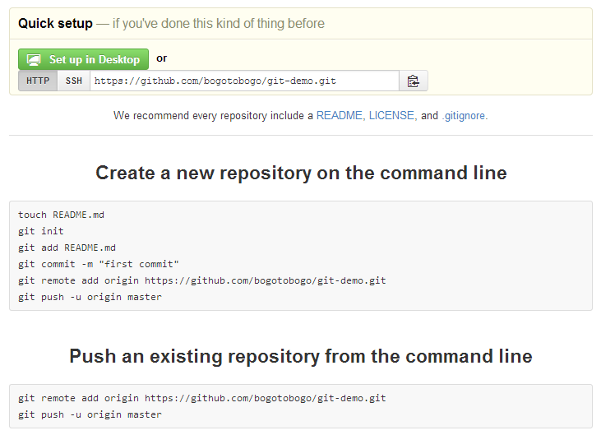

How to connect to GitHub Account

To upload to GitHub, we need to setup couple of things on client side:

1. Create SSH key - we'll be using RSA public/private cryptography
2. HTTPS or SSH - either one will work but GitHub prefers SHH

Creating SSH Key

We want to create a SSH key.

Type in **ssh-keygen -t rsa -C "email_address"** where **-t** allows us to set the key type:

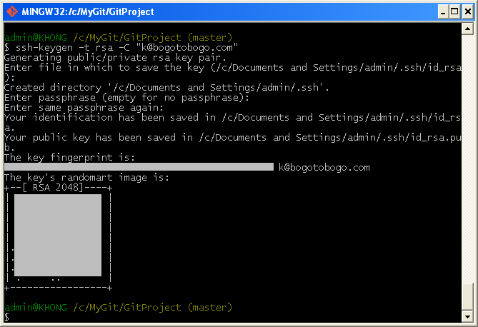

Then, go to the personal folder:

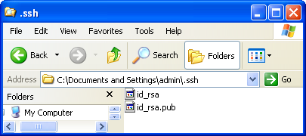

SSH Key to GitHub

Now we want to copy the key and put that into the SSH section of GitHub.

1. Copy the key:

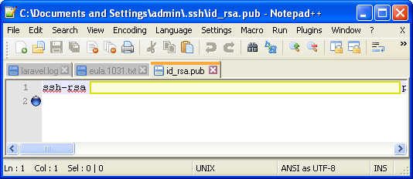

1. In GitHub site, Account Setting>SSH keys>Add SSH Key. Paste the key we copied. Then, click "Add key".

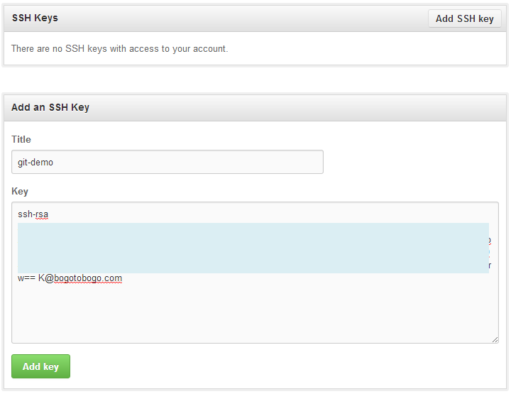  
  
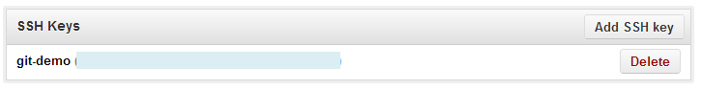

Checking SSH

We can check if it really works by running **ssh -T git@github.com** command:

